STUDENT |  | GRADER | Total Score
 |  |  | Total Score
  I am submitting my own work, and I understand penalties will
  be assessed if I submit work for credit that is not my own.
   | Print Name |  | ID Number
   | Sign Name |  | Date
  # | Points | Score
  1 | 12
  2 | 8
  3 | 20
  4 | 20
 |  |  | Weeks late
 |  |  | Adjusted Score
 |  |  | Adjusted Score
  Estimated Work Hours
  1 | 2 | 3 | 4 | 5 | 6 | 7 | 8 | 9 | 10
  1 | 2 | 3 | 4 | 5 | 6 | 7 | 8 | 9 | 10
  Overall Weight
Adjusted Score:
Deduct 20% from score for each week late

Problem 1. Assign state codes to the state diagrams below, and discuss the motivation behind your choice of state codes.

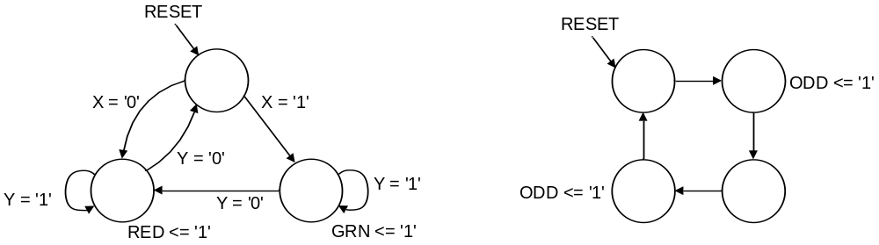

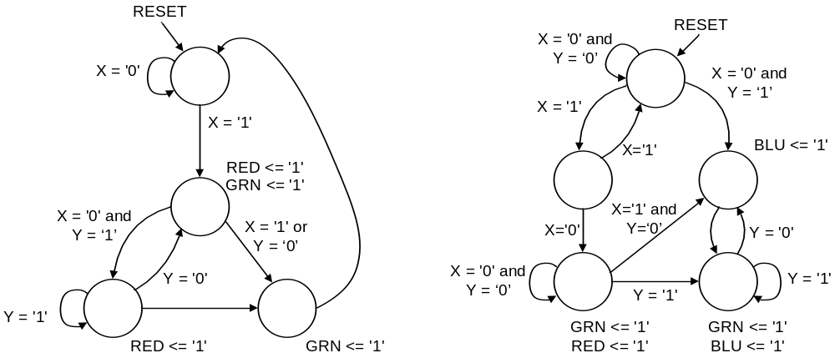

Problem 2. Modify the state diagram branching conditions in the diagrams below as needed to ensure the sum and exclusion rules are obeyed in each case. You can add a holding conditions or change branch codes as desired.

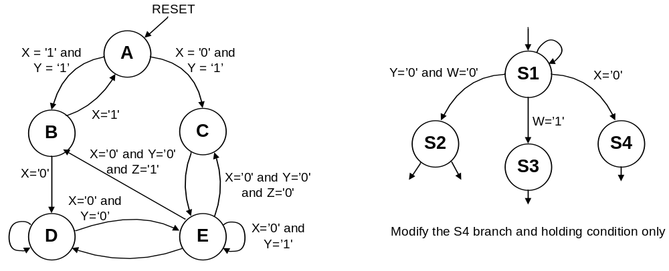

Problem 3. A vending machine should SELL an item if 30 cents is input. The machine has a coin sensor that can detect nickels, dimes, and quarters, and reject everything else. No change is given (i.e, if two quarters are input, simply assert SELL and keep the fifty cents).

B) Create a state diagram for a machine that can control a 4-button digital combination lock mechanism, unlocking only if the sequence B0-B3-B1 is detected.

Problem 4. Sketch circuits for the state machines below.

